## Romantic Bali 06 Nights / 07 Days

**Ex - Ahmedabad**

**Flight Details: -**

**Departure Dates: 13th Feb & 07th Mar 2020**

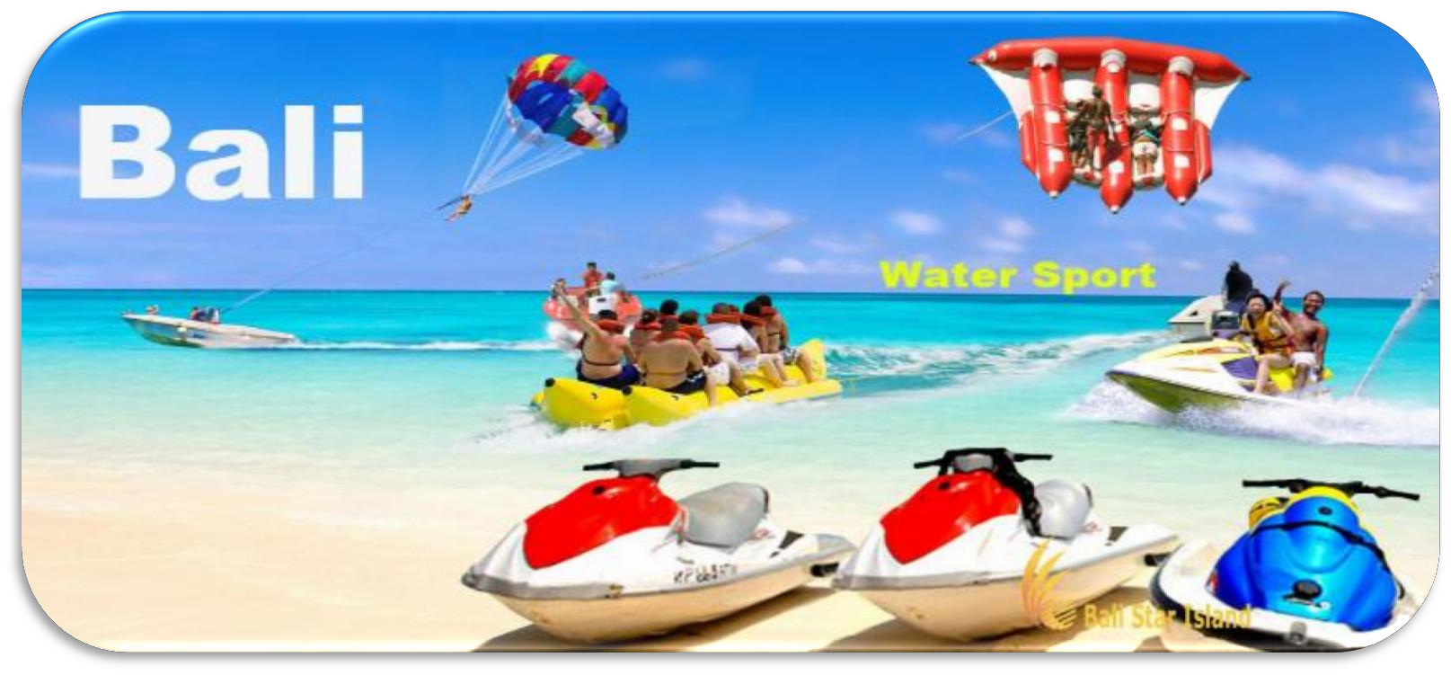

|  |  |  |  |  |
| --- | --- | --- | --- | --- |
| **SQ 531** | **AMD** | **SIN** | **2305** | **0715** |
| **SQ 942** | **SIN** | **DPS** | **0905** | **1150** |
| **SQ 943** | **DPS** | **SIN** | **1300** | **1540** |
| **SQ 530** | **SIN** | **AMD** | **1840** | **2150** |

**Hotel List:**

|  |  |
| --- | --- |
| **4 Night Hotel** | Risata Bali Resort OR Similar |
| **2 Night Private Pool Villa** | Furama Villa Resort & Spa OR Similar |

**Package Highlight:**

* Kintamani Volcano Tour
* Tanjung Benoa Water Sport Activity (Including 1 X Round Of Banana Boat, Parasailing / Flying Fish And Jet Ski (Parasailing Subject To Weather Condition)
* Tanah Lot Temple
* Ubud Village Tour + Shopping Tour
* 1 Hrs. Balinese Spa

**Meal:** 06 Breakfasts, 06 Dinners

**Tour Cost:**

|  |  |
| --- | --- |
| Adult | **85000/- INR** |
| Child Age Of 08 - 11 Years | **81000/- INR** |
| Child Age Of 02 - 08 Years | **77000/- INR** |
| Infant Below 2 Years | **19000 /- INR** |
| **5 % GST Will Be Applicable on Total Tour Cost** | |

**Optional:**

* **Candle Light Dinner**
* **White Water Rafting**
* **Bali Safari Tour**

## Package Does Not Include:

* **Any other sightseeing or meals which are not mentioned in above itinerary.**
* **Any Urgent visa charges**
* **We will not provide any refund if visa got rejected or any death or any other incident for cancellation.**
* **Travel insurance is not included.**
* **Surcharges apply if there any Fair or other surcharge or events.**

## International Hotel Timing:

Check-In Time : 03:00 Check-Out Time: 12:00

## Payment Terms: -

* **25,000 INR Deposit on Booking Time which is nonrefundable.**
* **Pan card copy is compulsory at the time of booking.**
* **Full Payment has to be clear before 30 Days of Departure& accepted only in INR.**

## Cancelation Policy: -

* **After booking, deposit Amount will be non-refundable.**
* **From 25 Days to Departure Date Full Tour Cost will be Non-refundable.**

## Note:-

* **Your passport has to be valid at least 9 months from the date of travel.**
* **It is Mandatory to keep US$ 700 per person as per rules.**
* **You can carry 10000/- INR per person as per rules**
* **Bliss Tours & Travels is not responsible for any natural calamity during tours or any other problems like road block, Riots, Disasters we will not able to do any refund like such a situation.**
* **All Travelers should reach at Airport before 3 Hrs of departure of Flight.**